University

University of Missouri – Computer Science 2050 –

Homework 1

Introduction

**No global variable are to be used in this homework. Please read this document in its entirety before beginning the homework. This homework is due Sunday, February 11th at 11:59 P.M.** In this homework you will be using the following: file input/output, pointer, structures and malloc. You will be given 3 input files all containing instances of players structures. You will scan the information from all 3 of the input files into the SAME array. After all of the players have been scanned in from each file, you will use the calculate_slugging function to figure out each players slugging percentage and store that in the Slugging_Percentage variable in the structure. Note that you may have to typecast the variable as a double when doing the calculations. (See link at bottom of document). When the Slugging Percentages have been calculated, you will use the sort_array function(bubble sort) to sort the players in DESCENDING order by their slugging percentage. After they have been sorted, you will output the array to the output file specified on the command line argv[5]. Note that the array SHOULD BE sorted when it is output to the file. The input file’s for this lab can be found on blackboard in a zip folder under the assignments tab

Command Line Arguments

argv[0] - ./a.out (executable file)

argv[1] – the number of players in ALL the input files combined

argv[2] – input file 1

argv[3] – input file 2

argv[4] – input file 3

argv[5] – output file

**Note that each input file have the same amount of players in them, so if you are trying to figure out how many to scan in from each file try argv[1]/3.**

Functions

typedef struct player {

char Fname[25];

char Lname[25];

int Singles;

int Doubles;

int Triples;

int Homeruns;

int At_Bats;

float Slugging_Percentage;

} Player;

**//** This function will read in **size** struct players from **filename** and add these // the **players** array. The function will use **index**  to know where to start // writing the players to in the array.

// Parameters

//

// filename – The name of the input file

// players – a pointer to the array of player structures

// index – The index of the array to start placing players into

// size – The number of players in the input file

// Return - Nothing

**void read_from_file(**char* filename, Player* players, int index, int size);

// This function will take in an array of **players** and calculate their slugging // percentage using the other variables in the structure(Singles, Doubles, // Triples, Homeruns).

// Parameters

//

// players – a pointer to the array of Players structures

// size – the size of the array of structures

**void calculate_slugging**(Player* players, int size);

**//**This function takes in an array of **players** and will sort this array based on Slugging // Percentage. The formula for calculating slugging percentage can be found toward the // bottom of the document.

// Parameters

//

// players – a pointer to the array of Player structures

// size – the size of the array

// Return - Nothing

**void sort_array(**Player* players, int size);

// This function will take in a structure of **players** and print them into the // given

// output file, **filename**

// Parameters

//

// filename – the name of the output file

// players – a pointer to the array of struct players to write to the file

// size – the size of the **players**  array

// Return - Nothing

**void write_to_file(**char* filename, Player* players, int size);

How to calculate Slugging Percentage

To calculate slugging percentage, take the number of Total Bases (singles, doubles, triples and homers) and divide by At Bats. To add up Total Bases, each single counts for one, each double is two, etc.

For instance, in 1927, Babe Ruth had 192 hits. He had 29 doubles, 8 triples and 60 home runs, adding up to 97 extra-base hits; subtracting that from 192 leaves 95 singles. So you'd add 95 + (29 × 2) + (8 × 3) + (60 × 4) = 417 Total Bases. Divide that by the number of his At Bats that year, which was 540 and you get a slugging percentage of .772.

Typecasting Variables Link

<http://www.cprogramming.com/tutorial/c/lesson11.html>

Additional Notes

* To find out the number of hits a person has you simply need to add the number of singles, doubles, triples and homeruns.
* Use val command to check for memory leaks
* Take advantage of office hours next week
* Programs that do not compile will not be accepted for submission
* Programs with Segmentation faults will result in a minimum 50% deduction
* Programs with memory leaks will result in a minimum of 10% deduction

Sample Output

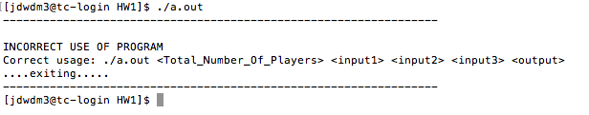

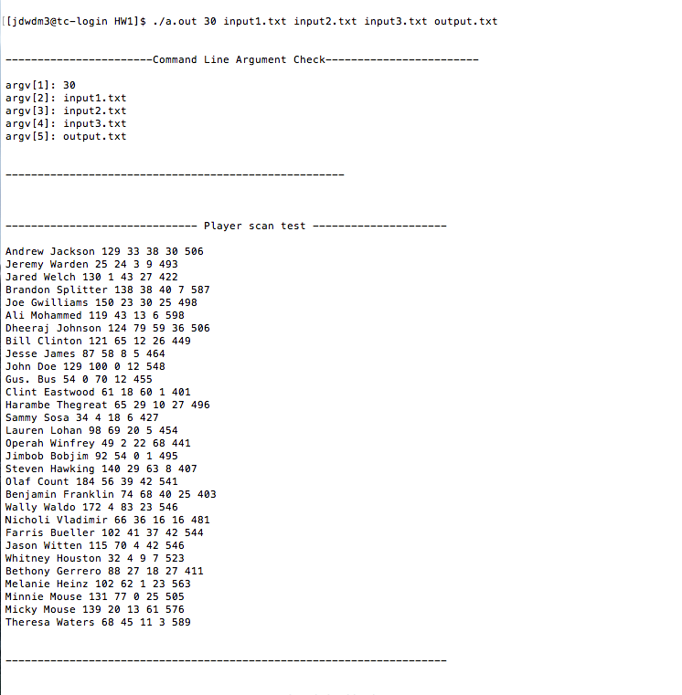

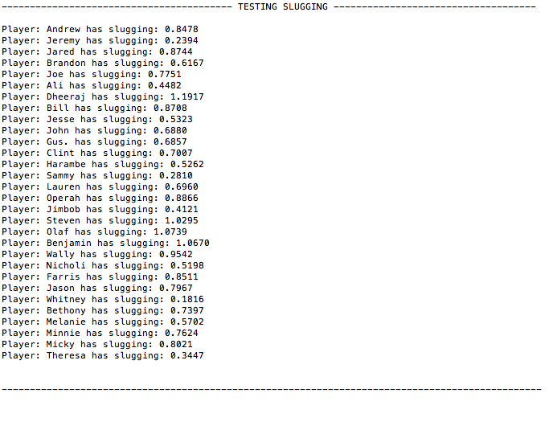  
  
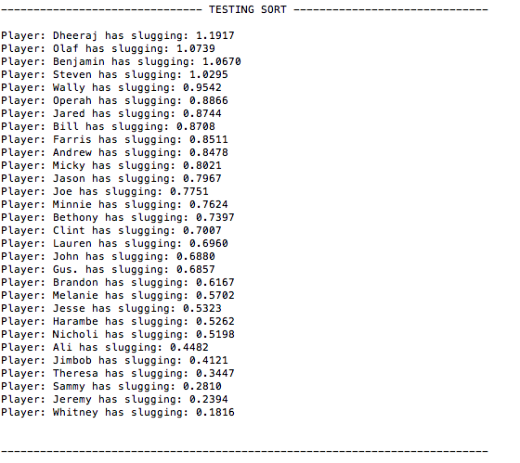

PLEASE NOTE NONE OF THE OUTPUT MATTERS OTHER THAN OUTPUT.TXT!!! I AM JUST DEMONSTRATING THE ORDER THIS PROGRAM CAN BE TESTED IN AND VISUALIZING IT FOR YOU ALL!!!

../Desktop/Screen%20Shot%202017-02-01%20at%2011.11.55%20PM.png

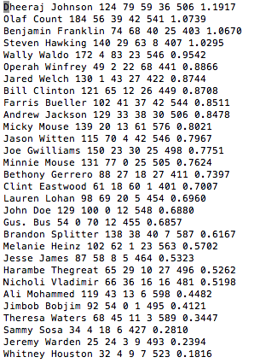

**GRADING CRITERIA**

**read_from_file: 10**

**write_to_file: 10**

**calculate_slugging: 15**

**sort_array: 15:**

**main: 10**

**total: 60**